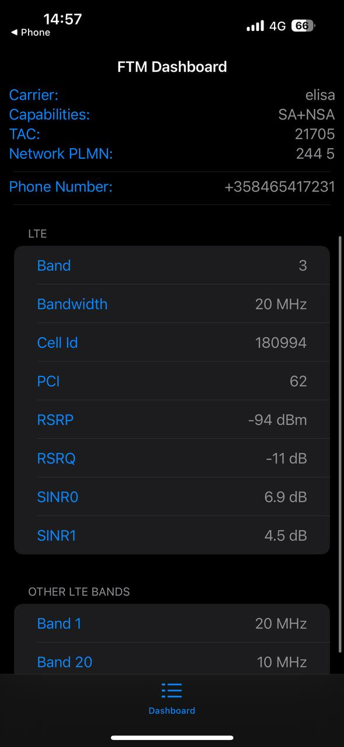
Service Mode Exploration – Wireless and Radiotechnology Course 2026
Objective
The objective of this experiment was to explore the smartphone service mode and analyze cellular network parameters such as signal strength, signal quality, frequency band, and bandwidth, and to understand how they affect network performance and reliability.
Device and Network
- Operator: Elisa (Finland)
- Network Technology: LTE (4G)
- Service Mode: FTM Dashboard
Measured Parameters (from Service Mode)
Parameter | Value
LTE Band | Band 3 (1800 MHz)
Bandwidth | 20 MHz
RSRP | −94 dBm
RSRQ | −11 dB
SINR | 6.9 dB
Cell ID | 180994
PCI | 62
Additional available bands:
- Band 1 (20 MHz)
- Band 20 (10 MHz)
Measurement Conditions
- Measurement was taken indoors, away from the base station
- The device was not placed directly near a window
- Network technology used: 4G LTE
Analysis
- Signal Strength (RSRP −94 dBm):
Indicates a medium signal level. The connection is usable, but not optimal.
- Signal Quality (RSRQ −11 dB, SINR 6.9 dB):
Shows moderate interference and noise, likely caused by indoor walls and distance from the cell tower.
- Bandwidth (20 MHz):
Provides good potential data speed, especially when combined with carrier aggregation.
- Impact on Performance:
  - Data speed is acceptable but may fluctuate
  - Network stability is generally good
  - Reliability can decrease during high network load or deeper indoor usage
Influencing Factors
- Distance from the cell tower
- Indoor obstructions (walls, floors, building materials)
- Network load and surrounding environment
Conclusions
The experiment shows that signal strength and signal quality significantly affect data speed and network stability. Indoor environments reduce signal quality due to physical obstructions, even when sufficient bandwidth is available. Better performance can be achieved near windows, outdoors, or by switching to 5G when available.

